( Wesite Design Brief.)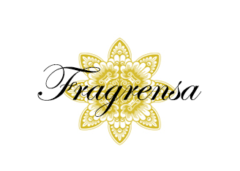

Table content

1.Introduction .

2.About The Organisation.

3.Target Audience.

4.Website Activities .

5.Navigation Structure.

6.Website Features.

7.Compeditor Websites.

8.Design.

1. Introduction

This website is the official micro website of the perfume making company Fragrensa.It tells us all about the organization and provides online sale of its products.

2.About The Organisation.

“Fragrensa”derived from the word fragrance.This company is newly born it focuses on wide range of femanine perfumes .Its perfumes are all made from natural products and suits all skin types.All of its products are very much skin friendly.

3.Target Audience.

Its primary and sole target audience are women belonging to an age limits

between 20 to 40.

4.Website Activities .

The users can perform the following activities:

a. Get all information about the company.

b. Purchase the products online.

c. Search stores nearby.

d. Follow on social media.

INFORMATION ARCHITECTURE.

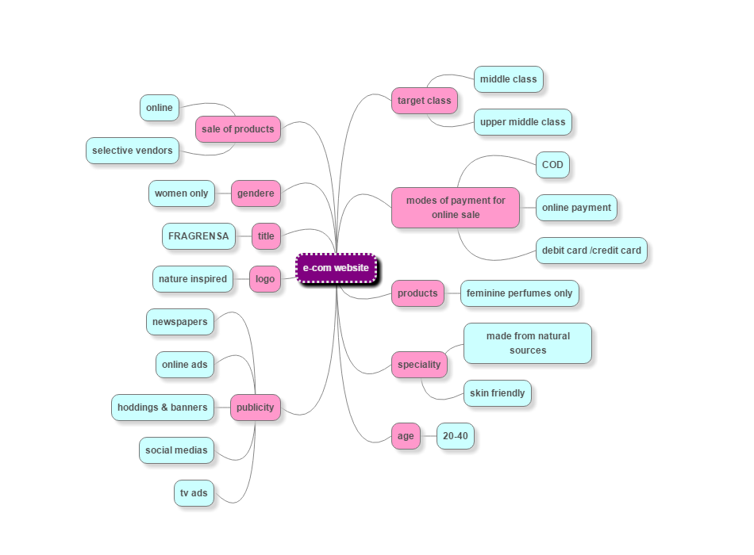

5.Navigation Structure.

SITE MAP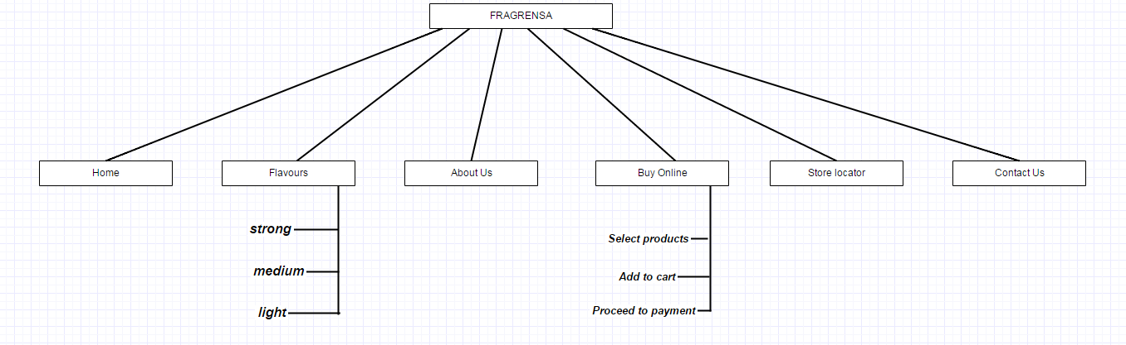

6.Website Features.

a.Online purchase of perfumes.

b.Locates nearby stores for offline purchase.

7.Compeditor websites.

|  |  |  |  |  |
| --- | --- | --- | --- | --- |
| 2013 | *Guess Girl* | [Guess](https://en.wikipedia.org/wiki/Guess_%28clothing%29) |  |  |
| 2014 | *Hello* | Harvey Prince |  | [[19]](https://en.wikipedia.org/wiki/List_of_perfumes#cite_note-19) |
| 2014 | *Petaly Noir* | Harvey Prince |  | [[20]](https://en.wikipedia.org/wiki/List_of_perfumes#cite_note-20) |
| 2014 | *Vince Camuto for Men* | [Vince Camuto](https://en.wikipedia.org/wiki/Vince_Camuto) | Steve Demercado |  |
| 2014 | *Salvador Dali La Belle et l'Ocelot* | [Salvador Dali Parfums](https://en.wikipedia.org/w/index.php?title=Salvador_Dali_Parfums&action=edit&redlink=1) | Henri Bergia |  |
| 2014 | *Reveal* | [Calvin Klein](https://en.wikipedia.org/wiki/Calvin_Klein) | Jean-Marc Chaillan, Bruno Jovanovic |  |
| 2014 | *Cuir Cannage* | [Dior](https://en.wikipedia.org/wiki/Dior) | François Demachy |  |
| 2014 | *L'Occitane en Provence Aguape* | [L'Occitane en Provence](https://en.wikipedia.org/wiki/L%27Occitane_en_Provence) |  |  |
| 2015 | *Magnificent Blossom* | [Yves Saint Laurent](https://en.wikipedia.org/wiki/Yves_Saint_Laurent_%28brand%29) |  |  |
| 2015 | Lotus Oud | Lotus co |  |  |
| 2015 | Lotus fraiche | Lotus co |  |  |
| 2015 | Lotus intense | Lotus co |  |  |
| 2016 | *Clammy* | [Sophie Banks](https://en.wikipedia.org/w/index.php?title=Sophie_Banks&action=edit&redlink=1) |  |  |
| 2016 | *Fragonard Iris* | [Fragonard](https://en.wikipedia.org/wiki/Fragonard) |  |  |
| 2016 | *L`Occitane Dama da Noite* | [L’Occitane au Brésil](https://en.wikipedia.org/w/index.php?title=L%E2%80%99Occitane_au_Br%C3%A9sil&action=edit&redlink=1) | Marion Costero |  |
| 2016 | *Muguet 2016 Guerlain* | [Guerlain](https://en.wikipedia.org/wiki/Guerlain) | [Jacques Guerlain](https://en.wikipedia.org/wiki/Jacques_Guerlain) |  |

8.Design.

